**SuperStore Data Analysis**

## We have superstore data and we have to find

* Which order priority has the most?
* Which city or state receives the highest sales or orders?
* Which product has the highest sales or orders?
* Which department of products has the highest sales?
* Which product brings in the most profit?
* Which product has high sales but less profit?
* Which product has the highest profit margin?
* Which mode of shipping has the highest demand?
* Which customer segment generates the most revenue?
* Which time of year experiences the highest sales volume?
* Gap between order date and ship date?

Result:

* **Which order priority has the most?**

After analyzing we have most of the orders of hihg prioriy category followed by Low then medium and critical.

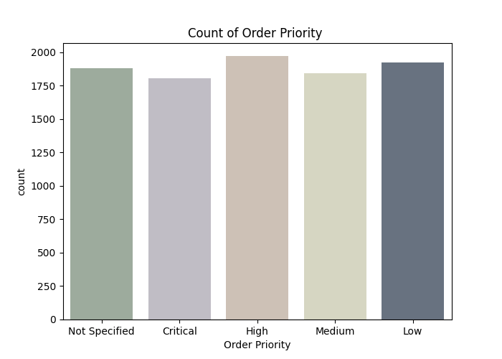

* **Which mode of shipping has the highest demand?**

After analyzing data we find out Regular Air has high shipping rate place followed by truck truck and Express Air

And Regular Air has high cost followed by truck then express air.

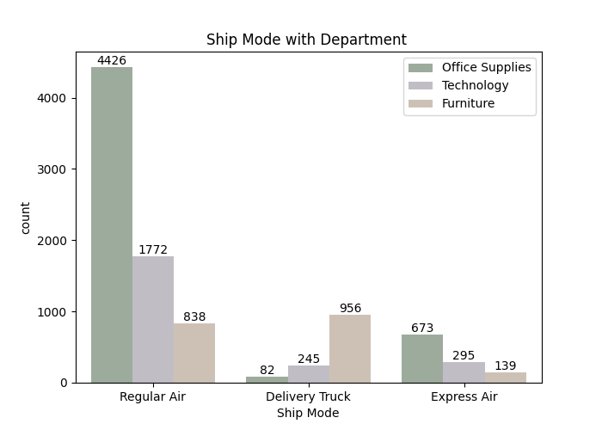

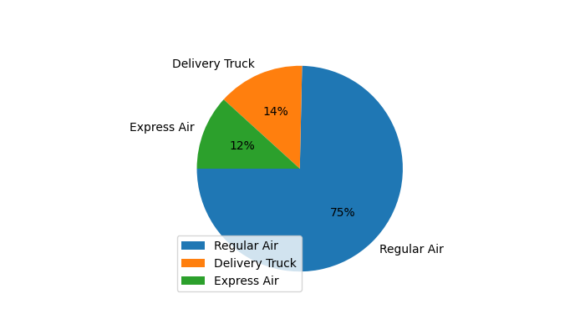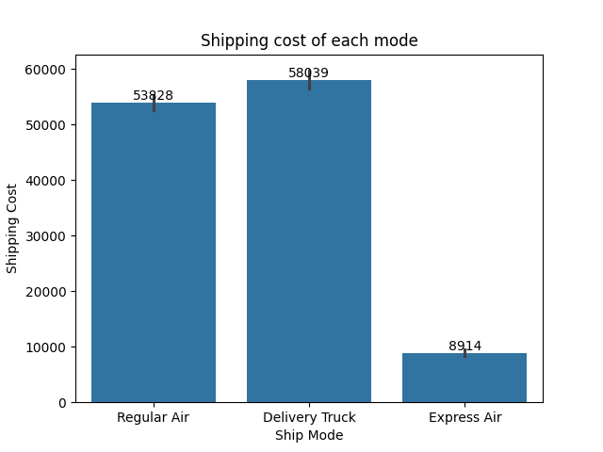

* **Which city or state receives the highest sales or orders?**

# **Top 5 state regarding orders**

* Texas 1029
* Massachusetts 878
* California 798

#### New York 469

* Florida 382

# **Top 5 cities regarding orders**

* Oxford 438
* Boston 305
* Irving 262
* Southbury 177
* Santa Rosa 109
* **Which product has the highest sales or orders?**

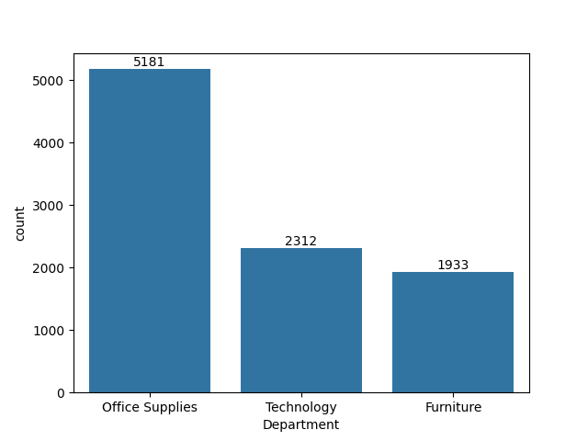

* **Which product brings in the most profit?**

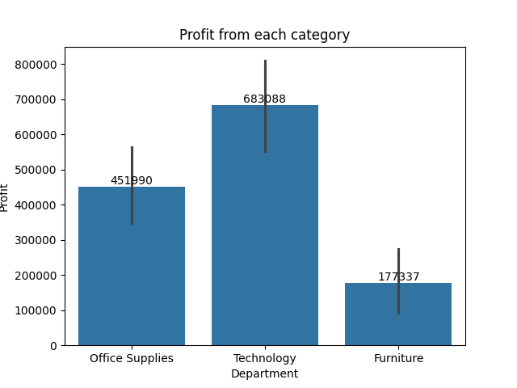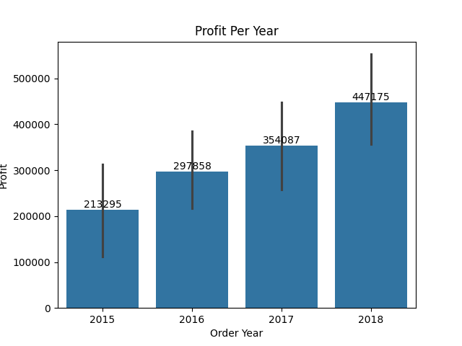

* **Which product has the highest profit margin?**

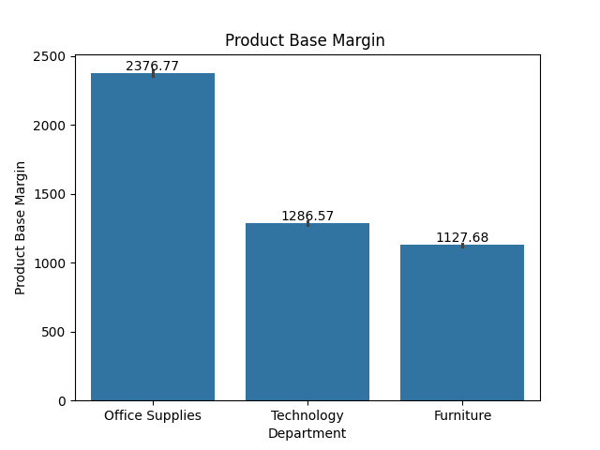

* **Gap between order date and ship date?**

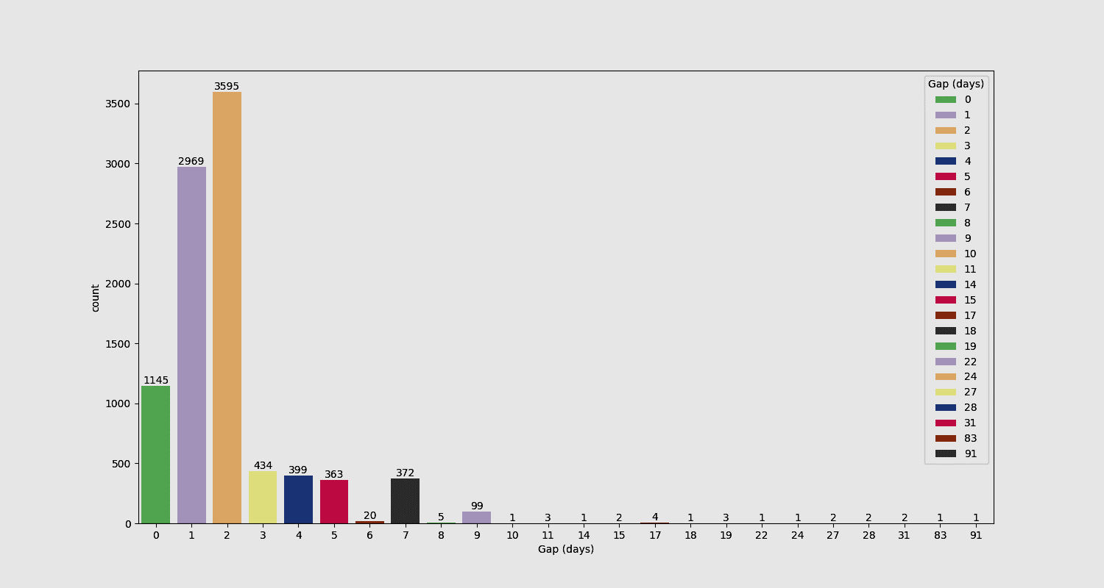

* **Which customer segment generates the most revenue?**
* 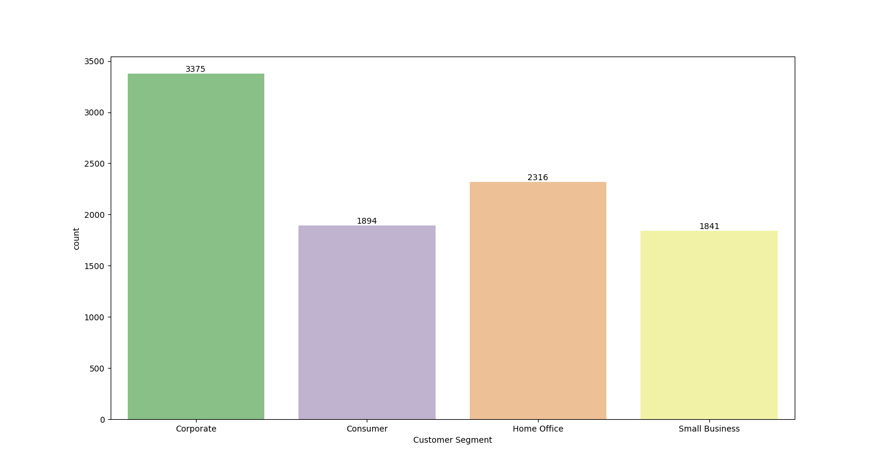

**By**

##### **Baidar Ahmad**

**Data Analyst**

<mailto:baidarahmad417@gmail.com>

**peshawar pakistan**